Computer Graphics

final Report



Ripesh Ale Magar | 2217032

Susani Antony | 2217152

2023/12/06

Submitted to:

Prof. Zubair

**Abstract:**

**The project aims to provide an in-depth exploration of 2D graphics rendering through the implementation of a diverse and visually captivating scene using OpenGL. This report presents an extensive breakdown of the code structure, OpenGL functions, and graphic elements employed to create a detailed 2D environment, offering an educational resource for understanding fundamental concepts in computer graphics programming.**

1. Introduction:

# 1.1 Project Overview:

* Description of the project's scope, emphasizing the educational and demonstrative aspects of OpenGL in 2D graphics programming.

# 1.2 Objectives:

* Detailed objectives, including the demonstration of key OpenGL functions, geometric rendering techniques, and the creation of an intricate 2D scene for educational purposes.

2. Technical Environment**:**

# 2.1 Libraries Used:

* Comprehensive explanation of **<GL/glut.h>**, **<GL/GL.h>**, **<GL/GLU.h>**, and **<windows.h>**, elucidating their roles in facilitating OpenGL functionalities

.



# 2.2 Window Initialization:

* Detailed breakdown of the **glutInit** functions and their significance in initializing the OpenGL environment.
* Explanation of configuring display settings and creating the rendering window.

3. Initialization and Configuration:

# 3.1 init() Function:

* In-depth analysis of the **init()** function, focusing on:
  + Utilization of **glClearColor()** to set the display window's background color.
  + Explanation of setting up 2D projection parameters using **glMatrixMode()** and **gluOrtho2D()**.

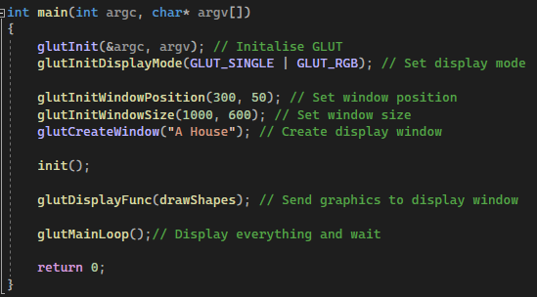

4. Drawing Shapes and Elements:

# 4.1 drawShapes() Function:

* Comprehensive breakdown of the function's components:
  + Layered Background Rendering:
    - Implementation of multi-colored polygons for the background layers.
  + Landscape Elements:
    - Detailed creation of mountains using **GL_TRIANGLES**.
    - Depiction of the house with roof, body, door, and windows employing **GL_QUADS** and **GL_POLYGON**.
    - Representation of trees, roads, and environmental details using various primitive types.
  + Flag Visualization:
    - Rendering a flag with multiple colored polygons and lines, explaining each step.
  + Sun and Circles:
    - Creation of circular elements representing the sun and other relevant objects.
  + In-depth explanation of vertex specifications and color representation techniques.

5. Explanation of OpenGL Drawing Commands**:**

# 5.1 Overview of Drawing Commands:

* Detailed explanation of essential OpenGL drawing commands:
  + Application of **glBegin()** and **glEnd()** for defining shapes.
  + Explanation of primitive types such as **GL_POLYGON**, **GL_TRIANGLES**, etc.
  + Vertex position specification using **glVertex2i()** and **glVertex2f()**.
  + Manipulation of colors via **glColor3f()** for visual representation.

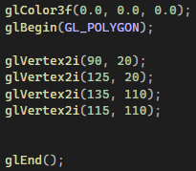

# 5.2 Advanced Drawing Techniques:

* Further exploration of advanced drawing techniques, if applicable, such as blending modes, texture mapping, or shaders, and their potential role in enhancing the scene.

6. Geometry Creation:

# 6.1 Geometric Techniques:

* Comprehensive explanation of geometry creation techniques:
  + Trigonometric methods for circle drawing using **GL_TRIANGLE_FAN**.
  + Triangle rendering for the flag's graphical components or other geometric shapes.

